Title: Instructions for the drafting of the paper (the title must be in English)

of Mario Rossi*, Mario Bianchi**, Maria Neri**

Keywords: max 5, in English

Topic: number and name of the STC2019 topics (ex: 3. Strategies, methodological proposals and designs)

Abstract

The abstract must be written in English and must not exceed 1000 characters (spaces included). Font: Times New Roman. Font size: 10 pt, single line spacing. It is mandatory to copy and paste the text in this template respecting the spaces, the font size and all the indications provided. It is strictly necessary to follow the guidelines of this template without modifying it.

1. Title first section

Always leave two lines of space before each title and one after.
The paper must be written in English or in Italian with the abstract in English. It must have a maximum length of 10 pages (including the title in English and the title in Italian, the authors, the affiliations, the abstract, the keywords, any tables, figures, text, references and section titles) and a maximum size of 10MB. The format provided must be respected. The text must be in Times New Roman, 11 pt, justified, with single line spacing. It is mandatory to copy and paste the text in this format respecting the spaces, the font size and all the indications provided.
If there are any foreign words in the text, they must be written in italic.

1.1. Subsection title

Each inserted image must be recalled in the text as (Fig. 1) and must have a reference caption. The figures must be in jpg. format, 300 dpi, and have a maximum width of 17.23 cm. The text of the caption is Times New Roman, 9 pt, italic, and the source of the figure must be indicated as in the example of this template.
As for the lists, they can be numbered or staked as follows:

1. Using the Word numbered lists command

• Using the Word bulleted list command

Any tables must have their own caption (placed before the table) and must be indicated in the text as (Tab. 1). Also for tables, the maximum width should be 17.23 cm.
The bibliographic references must be inserted in the text in round brackets "(Author's Surname, year)", to which corresponds the Book / Article / Essay etc. reported in the bibliography.
It is also possible to insert footnotes at the bottom of the page.
The equations must be justified in the center, entered with the Word "Insert equation" command. They must be numbered (1) and indicated in the text as (Eq. 1).
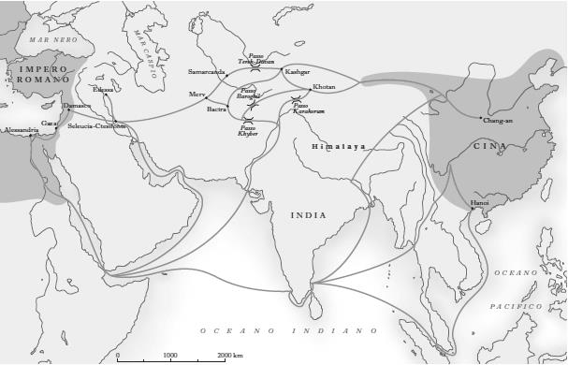
Fig. 1 – The different sections of the Silk Road during the Roman Empire - Source: www.treccani.it

Conclusions

For any info you can write to the Conference's e-mail address: stc2019@unisa.it

Bibliography

For the reference bibliography (written in alphabetical order. Font: Times New Roman, 10 pt, with single line spacing), the following example can be taken as a model respectively for Book, Curating, Essay in collective work or Book chapter, Magazine article:

Surname First Author, Dotted Name, Surname Second Author, Dotted Name [Year]. Title in italic, Publisher's headquarters: Publisher.
Surname First Author, Dotted Name, Surname Second Author, Dotted Name (edited by) [Year]. Title in italic, Publisher's headquarters: Publisher.
Surname Author, Dotted Name [Year]. "Title of the chapter or of the essay in quotation marks", in Surname Author of the Book, Dotted Name (edited by). Title of the book in italic, Publisher's headquarters: Publisher.
Surname Author, Dotted Name [Year]. "Title of the article", Name of the magazine in italic, n. volume, p. (or pp.) number or numbers separated by hyphen.

The Paper, both in Word and Pdf format, must be sent no later than the deadline (10.05.2019) to the e-mail address stc2019@unisa.it with the following heading: Corresponding Author’s Surname and Name _Paper_Paper’s title_Stc2019 (ex: Rossi Mario_Paper_A sustainable strategy for the valorization of Calcata in the Province of Viterbo_Stc2019).

* Institution, Country, email.address@domain.com
** University of Salerno, Italy, mariobianchi@unisa.it, marianeri@unisa.it
Space for footnotes, Font: Times New Roman, 9 pt.

